University Village
Contract Assumption

Available for Fall 2012-Spring 2013

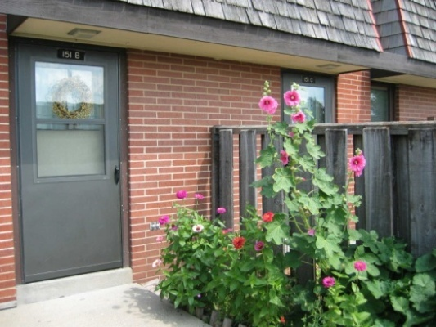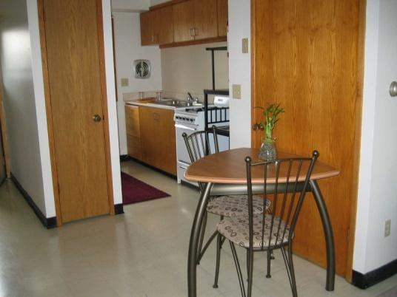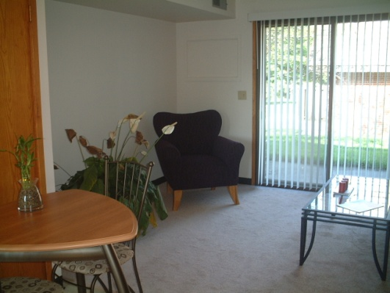
(Furnishings not included)

Apartment (Apt. #) $(Cost) per year

<<GENDER>> 2 Bedrooms, Air Conditioned, Unfurnished

Water, garbage, cable, and high-speed DSL internet service included in rent. You only pay gas and electric!

Call: (Phone Number) Email: (Email Address)

Name: (Your Name)  Phone: (Phone Number)  Email: (Email Address) | Name: (Your Name)  Phone: (Phone Number)  Email: (Email Address) | Name: (Your Name)  Phone: (Phone Number)  Email: (Email Address) | Name: (Your Name)  Phone: (Phone Number)  Email: (Email Address) | Name: (Your Name)  Phone: (Phone Number)  Email: (Email Address) | Name: (Your Name)  Phone: (Phone Number)  Email: (Email Address) | Name: (Your Name)  Phone: (Phone Number)  Email: (Email Address)

