Schilletter Village FAMILY
Contract Assumption

Available for <<SEMESTER>>

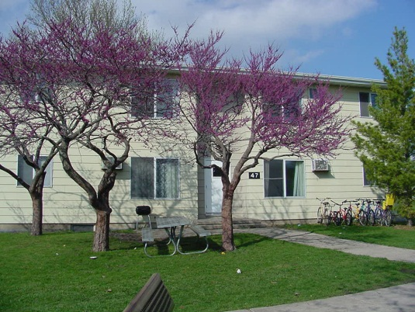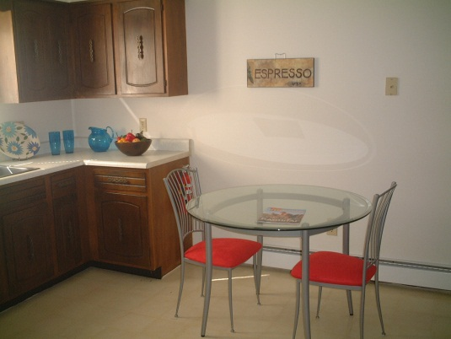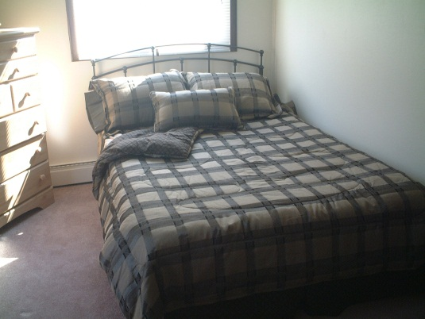
(Furnishings not included)

FAMILY Apartment (Apt. #) $(Cost) per year

2 Bedrooms, Air Conditioned, Unfurnished

Water, garbage, cable, and high-speed DSL internet service included in rent. You only pay gas and electric!

Call: (Phone Number) Email: (Email Address)

Name: (Your Name)  Phone: (Phone Number)  Email: (Email Address) | Name: (Your Name)  Phone: (Phone Number)  Email: (Email Address) | Name: (Your Name)  Phone: (Phone Number)  Email: (Email Address) | Name: (Your Name)  Phone: (Phone Number)  Email: (Email Address) | Name: (Your Name)  Phone: (Phone Number)  Email: (Email Address) | Name: (Your Name)  Phone: (Phone Number)  Email: (Email Address) | Name: (Your Name)  Phone: (Phone Number)  Email: (Email Address)

