Frederiksen Court
Contract Assumption

Available for <<SEMESTER(S)>>

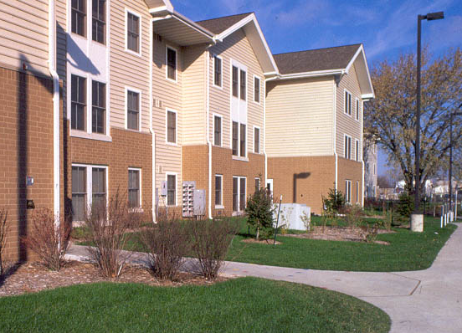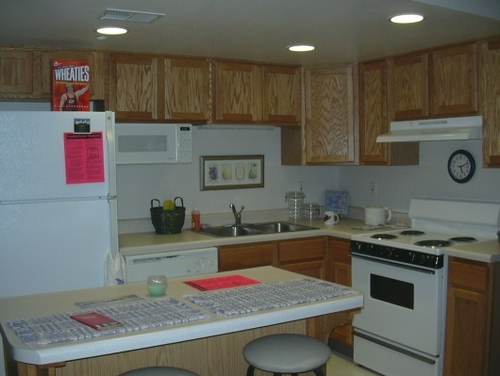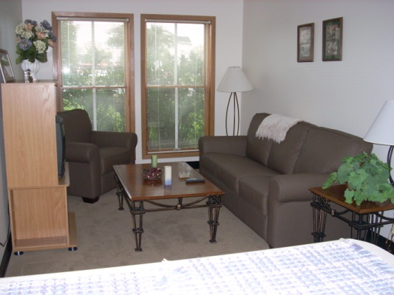

Apartment <<Apt. #>>

<<GENDER>> <<2 or 4>> Bedrooms $<<Cost>> per year

No Meal Plan Required  Fully Furnished  Washer, Dryer & Dishwasher | ALL Utilities Included  Air Conditioning  High Speed Internet | Close to Campus  Hawthorn Market & Café  Fitness Center

Call: (Phone Number) Email: (Email Address)

Name: (Your Name)  Phone: (Phone Number)  Email: (Email Address) | Name: (Your Name)  Phone: (Phone Number)  Email: (Email Address) | Name: (Your Name)  Phone: (Phone Number)  Email: (Email Address) | Name: (Your Name)  Phone: (Phone Number)  Email: (Email Address) | Name: (Your Name)  Phone: (Phone Number)  Email: (Email Address) | Name: (Your Name)  Phone: (Phone Number)  Email: (Email Address) | Name: (Your Name)  Phone: (Phone Number)  Email: (Email Address)

